**TSCC Meeting Minutes**

**July 15, 2019**

TSCC Offices, 808 SW 3rd Ave, Suite 540, Portland Oregon

Commissioners Barringer, Norton, Ofsink, Wubbold and Watkins were present as was Executive Director Gibons and Budget Analyst Tunie Betschart.

Absent: None

Chair Barringer convened the TSCC Regular Meeting at 12:03

1. Chair Barringer reviewed the minutes for June 12, 2019 Regular Meeting, Budget hearing minutes for Multnomah County, Multnomah County Library, East Multnomah Soil & Water Conservation District, Multnomah Education Service District, Metro, City of Portland, Port of Portland, Prosper Portland, Mt Hood Community College, Mt. Hood Community College and Portland Public School District #1 (with 2 corrections).
2. Craig Gibons review the TSCC FY19 Budget. (See attached)
3. Commissioners discussed budget season
4. PPS~ when conducting the Bond hearing be sure to remember that Promises made was to modernize schools.

Decided to include a question for the governing body as well as ask that any present at the hearing be introduced during introductions and ask if the board has any comments on anything that had been discussed during the hearing when making closing remarks. Discuss with staff any potential changes during the February-March staff to staff meetings. Apply this to all districts as needed.

1. Budget Hearing Duration~ For the following districts try to schedule 90 minutes for the hearing even though they may only last 60-75 minutes:

City of Portland, Port of Portland, PPS, TriMet and Metro.

When working with the staff mention we would like to limit introductory remarks/presentations to 15 minutes and do not include budget details; and TSCC will limit questions to 10.

1. Prosper Portland Budget Hearing delay~ Mr. Gibons will discuss the need to be more considerate of the TSCC Commissioners time in the future with Staff.

Future questions were discussed and may include:

* Current Projects; where are you now? On time, on budget? What’s going right/what’s going wrong? Lessons learned? Any redirection?
* Planned projects: why?  Background?
* (Or City of Portland) Close out old districts and get property back on rolls for all districts?

1. Mr. Gibons briefly discussed the letter sent by Mr. Kurkinen about Corbett School District concerning the Certification letter sent to the district by TSCC (See attached). Commissioners asked Mr. Gibons to respond with a thank you for the letter and advise him of the commissioners plan to monitor district’s spending and ensure that the entire board is aware of the TSCC’s actions and are receiving regular updates on the financial activities of the school district.
2. The DOJ Letter: Who is a citizen was discussed briefly. It was decided tax payer referred to in the ORS means property tax payer, both individuals and corporations and Mr. Gibons will modify policy to so state.
3. The Work Plan (See attached) was discussed at length.

* Replacing Executive Director ~ Mr. Gibons was asked to update the job description as review/update procedures. Recruitment would begin with local avenues such as League of Oregon Cities, OGFOA, and other various financial institutes for networking. Commissioners will work toward this in the fall. Possibly use a constituent district’s HR service for recruitment, salary range information, and background checks.
* Staffing~ This recruitment will begin soon for a part time person to do administrative type tasks.
* 100 Year acknowledgement celebration~ Need to decide when the celebration will take place and what activities will be planned. To be discussed at a later meeting this fall.
* Vice Chair Ofsink moved to approve the FY 2019-20 Work Plan as presented. Commissioner Watkins seconded the motion.

1. Chair Barringer adjourned the meeting at 1:47 pm.

Attachments:

1. TSCC Budget Analysis FY19
2. Corbett School District: Andrew Kurkinen Letter, district response to TSCC, and TSCC statutory outline
3. FY 2019-20 Work Plan (CLG draft, edited by Commissioner Ofsink)

**Approved by Commission at August 13 meeting**

Craig Gibons, Executive Director



**Corbett School District: Andrew Kurkinen Letter**

Dear Mr. Craig Gibons and Other Members of TSCC,

On June 4th of this year, TSCC sent a letter to Corbett School Board chair, Michelle Vo.

Please see attached for reference.

Of note was the language stating,

"The audit for the year ending June 30, 2018 noted the following over-expenditures:

General Fund:

Instruction $262,482

Support Services $241,300

Food Service Fund Enterprise and Community Services $ 38,803

"For a district of Corbett’s size, the General Fund’s over expenditures are an extreme and significant oversight. This is exacerbated by the district’s history of overspending its legal appropriations. Only once in the past several years has the district stayed within its legal appropriations."

As a parent with children in the district and a taxpayer, I am concerned about this issue and wondering what recourse, would occur to CSD, if any, if the school board did not comply with your recommendations and helpful suggestions, of which there were several, and show improved fiscal management in these categories.

In TSCC's closing statement:

"the board must pursue an effective strategy that produces improvement. TSCC’s Approved Budget recommendations must be addressed in writing in your 2019-2020 budget resolution."

If a school board repeatedly overspends it's legal limits and does not show improvement, is there potential for TSCC to vote to not approve CSD's submitted budget in a future calendar year or take other action?

Or is TSCC simply an advisory body?

At last night's school board meeting, the full board voted and approved the CSD 2019/20 budget, but TSCC's letter was not mentioned or discussed.

Thank you for representing the interests of taxpayers and for increasing accountability and transparency among Multnomah Counties' governing bodies.

Respectfully,

Andrew Kurkinen

District Parent and Property Owner

5038759093

**Corbett School District: Board Response to TSCC Cert Letter**

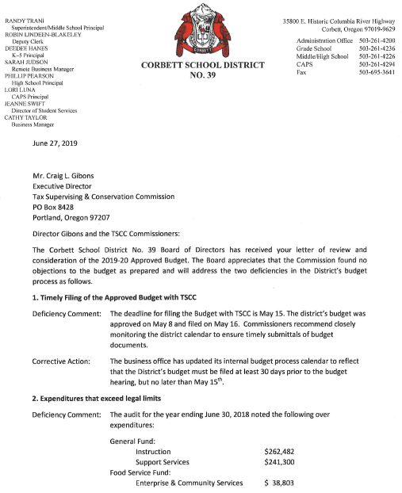

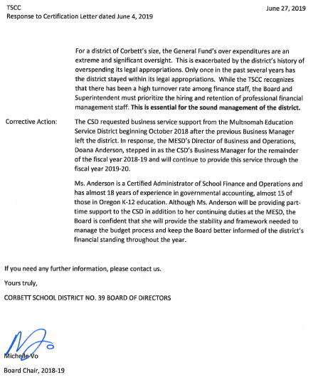

**TSCC Powers Summarized**

**II. Powers**

**294.645 Certification**

* After the hearing, the commission shall certify if it has any objections or recommendations regarding the budget.
* The responsibility of the commission is advisory only

**294.650 Commission Powers**

* Commission can order district to strike any expenditure not authorized by law and reduce any tax levied to pay expenditure
* Commission can order the district to reduce a tax levy in excess of that allowed by law

**294.670 District Books and Commission Rules**

* Commission may inquire into books and accounts of districts
* Commission may establish rules and regulations to carry out the purposes of local budget law

**294.990 Penalties**

* Districts that fail to submit budgets on time are subject to a $50 per day penalty
* Districts that do not attend a budget hearing are subject to a $25 fine for each board member refusing to attend.

**294.675 Joint Meetings**

* Commission may call joint meetings of districts for discussion of
  + Common problems
  + Financial planning
  + Building programs
  + Special levies
  + Bond issues
  + Cooperative ventures

**294.680 Excessive Expenditures**

* If at any time the commission finds that any municipal corporation, or public official thereof, has expended any public money in excess of the amounts or for any other or different purpose or purposes than is authorized by law, the commission shall certify to the district attorney for the county that fact, and the district attorney shall proceed for the recovery thereof as by law provided.

**FY 2019-20 Work Plan (CLG draft, edited by Commisioner Ofsink)**

**Replace Executive Director**

* Refine and start recruitment process.
* Update all procedures.
* Isolate policies separately from procedures.
* Fine tune data base inputting processes.
* Document process of report writing in Dataccuity.
* Explore options and costs of integrating our standalone computer network and into County network (maintain web TSCC web site separately from county).
* Clean up old electronic files.
* Find and adopt an automated web-based agenda and agenda document control system for transparency and document control.

**Recruit new commissioner**

* Search for someone with local government/school district budget/finance knowledge.
* Recruit from district budget committees.

**Staffing Plan: Recruit for an administrative assistant who is well organized and computer/electronic media savvy**

* Part time position with hours set as regularly as possible.
* Key components of position:
  + Organize meetings, budget hearings, and tax measure hearings and prepare agendas
  + Manage agenda documents
  + Maintain web site
  + Upgrade annual report design
  + Revise and automate forms and maintain document and process flow logs
  + Input data into Dataccuity

**100 year acknowledgement and celebration**

* Guide Commission brainstorming sessions to plan celebration.

**Write History of TSCC, at least the last 10 years**

* The last documented history of the TSCC was written in 1956.
* Search hard files for historical documents, policies, decisions, etc. Inventory and document all.
* At a minimum, write a history of TSCC beginning with the 2009 legislative session actions and events since then.

**Continue working on digital communications**

* Improve Update preparation using google alerts.
* Explore ways of overcoming Pamplin Media requirement to register to read articles.
* Showcase districts in the Update (create content).

**Keep up with ideas about how to improve quarterly meetings**

* The point of this is to build budget community. The effort failed as attendance dropped from 30 in initial sessions to 5 at the last meeting. Should be restarted carefully, perhaps as an integrated effort to showcase districts in the Update.