TSCC Meeting Minutes
February 3, 2020
TSCC Offices, 808 SW 3rd Ave, Suite 540, Portland Oregon

Commissioners Barringer, Ofsink, Norton, Wubbold, and Quiroz were present as were Executive Director Craig Gibons, Budget Analyst Tunie Betschart and guest Sydney Crawford.
Chair Barringer convened the TSCC Regular Meeting at 12:05
- Chair Barringer approved the January 7 meeting minutes with no corrections.
- Executive Director Gibons gave highlights about the Local Budget Law Training that was give the previous month. A new element was added to the training this year. Guest speakers from Parkrose School district spoke for approximately an hour about how they put their budget together following Local Budget Law. He distributed the training survey from the second session (the survey results from the first session were in the packet). The surveys indicated satisfaction with the training.
- Four Staff members from Levee Ready Columbia attended the Local Budget Law Training. They were very attentive, had many questions and comments during the training. They requested TSCC staff to help with their first budget. Staff has set up an appointment to meet with them at their office on February 19.
- Craig Gibons reviewed the TSCC FY20 Budget & the FY21 Proposed Budget (which he consolidated into one document for easy comparison) in detail. (See attached page with Update: 1-27-20).
  - The changes included strategic planning facilitation, graphic artist for new logo, Depart of Justice opinion, unanticipated salary costs and additional costs of staffing. The Adopted FY20 budget went from $348,800 to $369,650 with the changes.
  - There was discussion about the impact of these additions to the approved budget. With these changes, the TSCC budget exceeds the budget on file with the County. The question was asked if this would cause any problems with the County because of this. The budget sent to the County was $365,000. Mr. Gibons explained that he had talked with Mike Jaspin who said if we go a little over he would make adjustments. Our appropriations are combined with other Non-Departmental entities and so there is some “wiggle room” in the budget.
  - Commissioner Ofsink moved to approve the Revised FY 20 budget. Commissioner Wubbold seconded the motion which carried with a unanimous vote.
  - After some conversation about the FY21 proposed budget (updated 1-27-20) Commissioner Quiroz moved to approve the Proposed 2020-21 budget as presented. Commissioner Ofsink seconded the motion which passed with a unanimous voted.
- Executive Director Recruitment Schedule was discussed.
  - Executive Director Gibons reported on the progress since the last meeting which includes scheduling a member panel for March 30 or April 2. Participants are listed on the Hiring Timeline. (see handout)
  - The job announcement will be posted Thursday February 13.
  - The Salary Survey prepared by Mr. Gibons was discussed. After some discussion it was decided the starting range for position will remain as is, with a top salary of about $125,000. This will leave some room for negotiation.
- The commissioners spent time discussing their progress on the branding exercises they each volunteered to tackle. The following were reviewed, discussed and revisions suggested:
  - Commissioner Quiroz shared some changes she wanted to make to the One-page Information Sheet on the benefits of TSCC. Commissioners suggested other changes to incorporate into the documents. She said she had the general concept and would take it from there.
  - Commissioner Ofsink’s TSCC in a Paragraph used for discussions describing the activities of TSCC needed a few edits and word changes which he completed during the meeting. He will send this completed version on to Mr. Gibons.
  - Commissioner Wubbold read and edited the Op-Ed for the Oregonian and after some discussion from the other commissioners will edit and make some changes making this a call to action to encourage people to the join us at the hearings.
  - Commissioner Norton’s Pre-Hearing Letter to be sent to district’s elected officials prior to Public Hearings on their 2020-21 Approved Budgets showing the changes made was ready to go. No more changes needed.
- There was some discussion on the design Commissioner Quiroz presented from graphic designer, Verelle Tomford. Commissioners had previously decided on two different designs as finalists for the new logo. They were presented in various forms. After some discussion it was decided to go the Option two. (see attached Verelle Tomford proposal Round 2) with some edits, such as having a gray scale option, changing the year on the 100 years of service logo, changing the horizontal option to a more centered design. Commissioner Quiroz will talk with designer to incorporate suggestions.
- There was a short discussion on what qualifies as a “tax Measure” for the purposes of holding a TSCC Hearing. Mr. Gibons presented the results of his morning’s research verbally on the issue: piecing together different parts of statutes indicate that that the statutes are confined to property tax levies.
- Next TSCC meeting will be in March or early April. Date, time and place to be determined.
- Chair Barringer adjourned the meeting at 1:38 pm.

Approved by Commission at April 15 meeting
CLG

Attachments:
- TSCC Budget Analysis FY20 Updated 1-27-20)
- Hiring Timeline & Memo(Updated 1-13-19)
- Verelle Tomford proposal Round 2

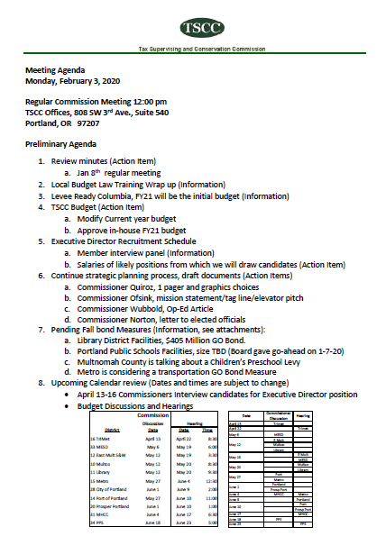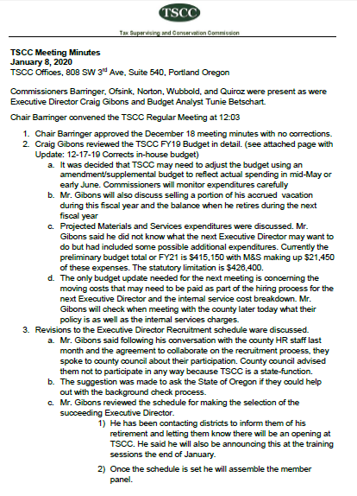

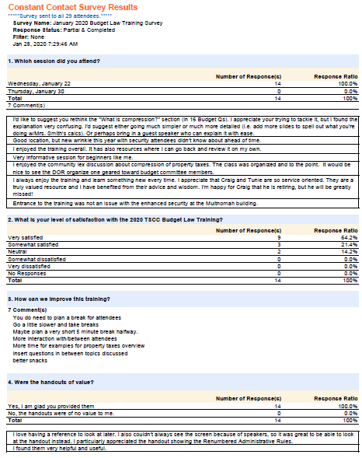

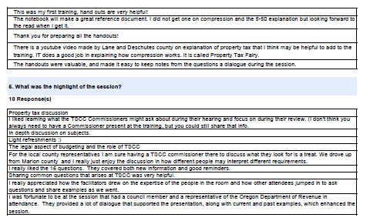

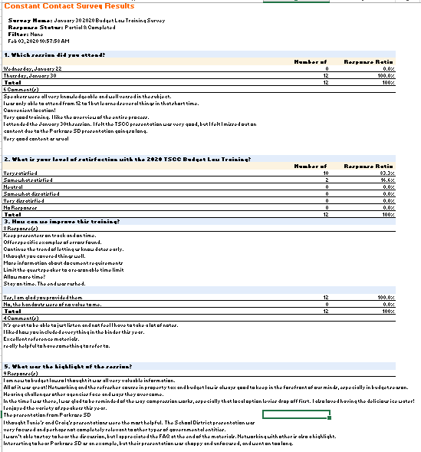

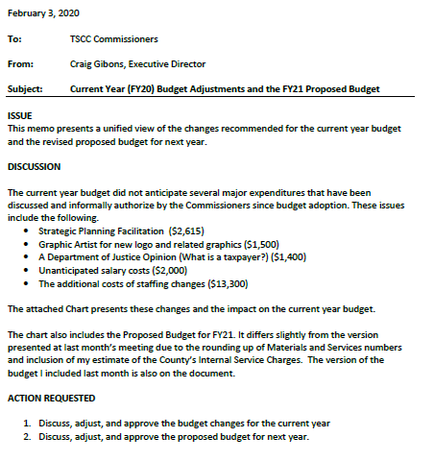

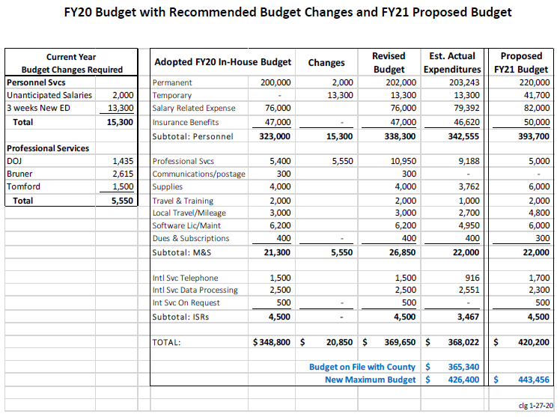

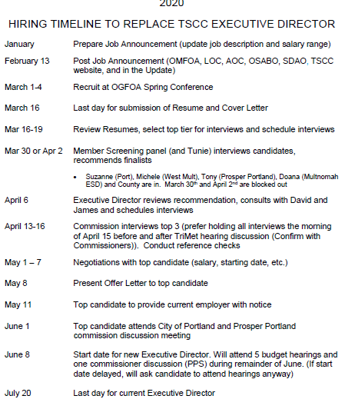

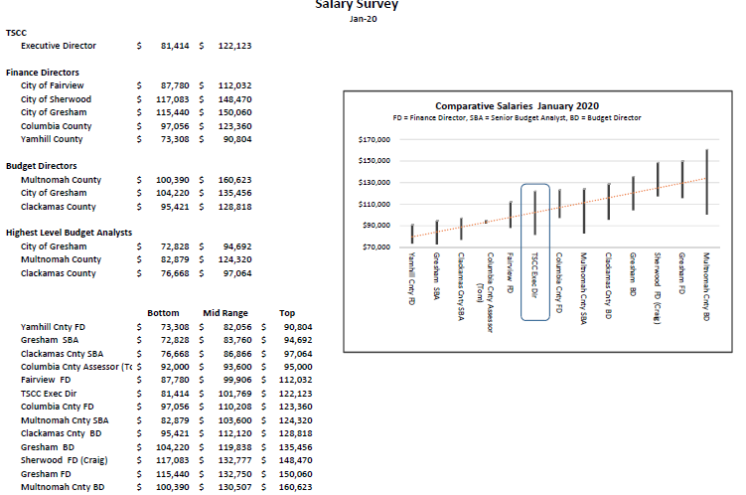

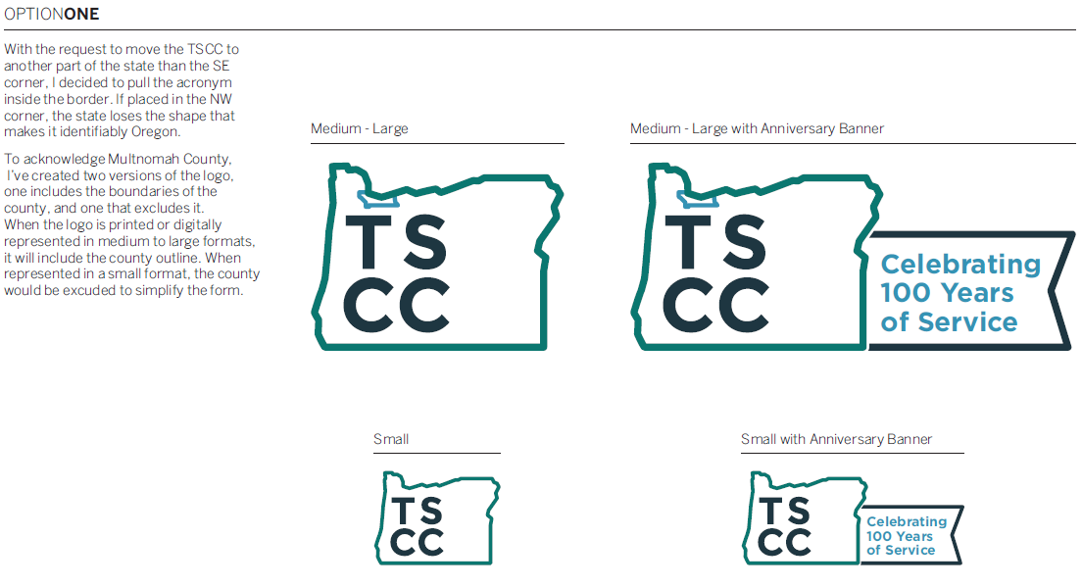

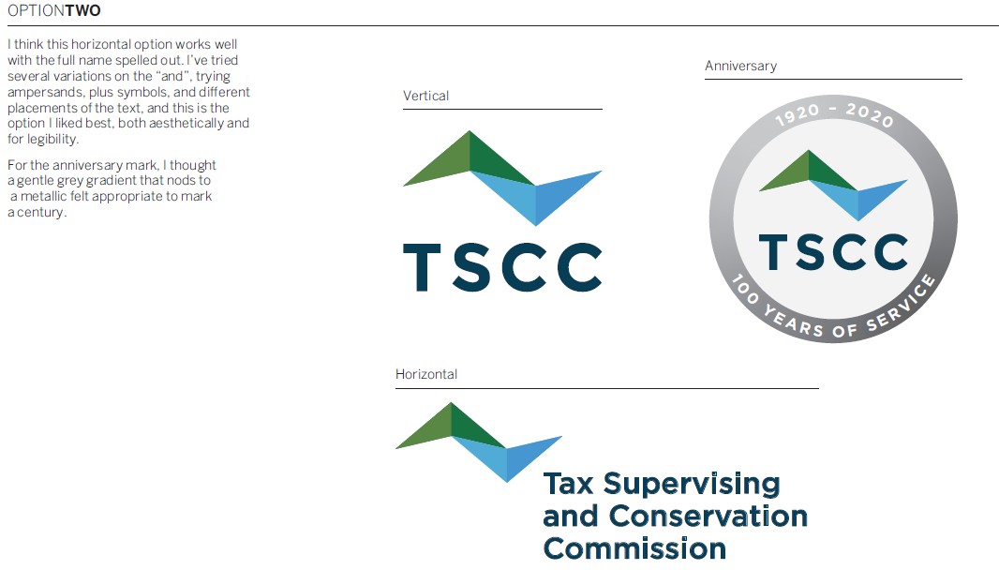

2017 ORS 294.655¹
Hearing on special tax levies and bond issues proposed for elector approval
The commission shall conduct public hearings on all special tax levies and bond issues proposed for elector approval by the levying boards. Any levying board proposing to ask elector approval of a special tax levy or of a bond issue shall notify the commission in writing of its proposal not less than 30 days prior to the filing date for the election and set forth its reasons therefor, but the commission in its discretion may permit such notification to be filed in such shorter period of time as it sees fit. Upon the receipt of the notification the commission shall fix the time and place of hearing and notify the levying board to attend the hearing and discuss the proposed special tax levy or bond issue with the commission. The hearings provided for in this section shall be in addition to the regular budget hearings provided for by ORS 294.640 (Hearing on budget)

